1. Which are the top three variables in your model which contribute most towards the probability of a lead getting converted?

Ans.

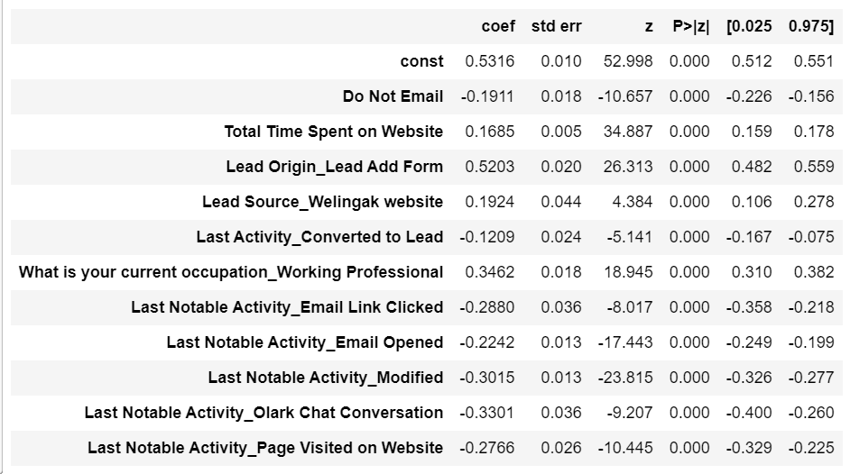

The following are the top three variables that contribute the most to the probability of a lead being converted, based on the coefficient values from the screenshot above:

* + Lead Origin_Lead Add Form
  + Lead Source_Welingak website
  + What is your occupation_Working Professional

1. What are the top 3 categorical/dummy variables in the model which should be focused the most on in order to increase the probability of lead conversion?

Ans.

The top three categorical/dummy variables in the model that should be prioritized in order to increase the likelihood of lead conversion are:

* What is your current occupation_Working Professional
* Lead Source_Welingak website
* Last Notable Activity_Email Opened

1. X Education has a period of 2 months every year during which they hire some interns. The sales team, in particular, has around 10 interns allotted to them. So during this phase, they wish to make the lead conversion more aggressive. So they want almost all of the potential leads (i.e. the customers who have been predicted as 1 by the model) to be converted and hence, want to make phone calls to as much of such people as possible. Suggest a good strategy they should employ at this stage.

Ans.

For making more aggressive lead conversation, a good strategy would be to make phone calls to people who:

* Spend a lot of time on the website, which can be accomplished by making the website interesting and thus attracting them back to the site.
* The ones seen returning to te website on a regular basis but haven’t enrolled yet, should be convinced and reassured with the packages and schemes of the company.
* The ones employed professionals, the ones who are looking for job switches but aren’t fully skilled.

We could also focus on a broader set of lead audiences (including leads with slightly lower conversion probabilities), we can change (move down) the value of the cut off to include more leads as hot leads from our Logistic Regression Model. By doing so, we will be better utilising resources and improving the chance of converting a lead with a low conversion probability.

1. Similarly, at times, the company reaches its target for a quarter before the deadline. During this time, the company wants the sales team to focus on some new work as well. So during this time, the company’s aim is to not make phone calls unless it’s extremely necessary, i.e. they want to minimize the rate of useless phone calls. Suggest a strategy they should employ at this stage.

Ans.

A good strategy would be to concentrate on a small number of lead audiences (while discarding lower conversion likely leads). Technically, we can generate this new set of leads by changing (moving up) the value of the cut off so that lower conversion rate probable leads are discarded from our Logistic Regression Model.

We will be putting in minimal effort while still getting fair conversions if we do it this way.